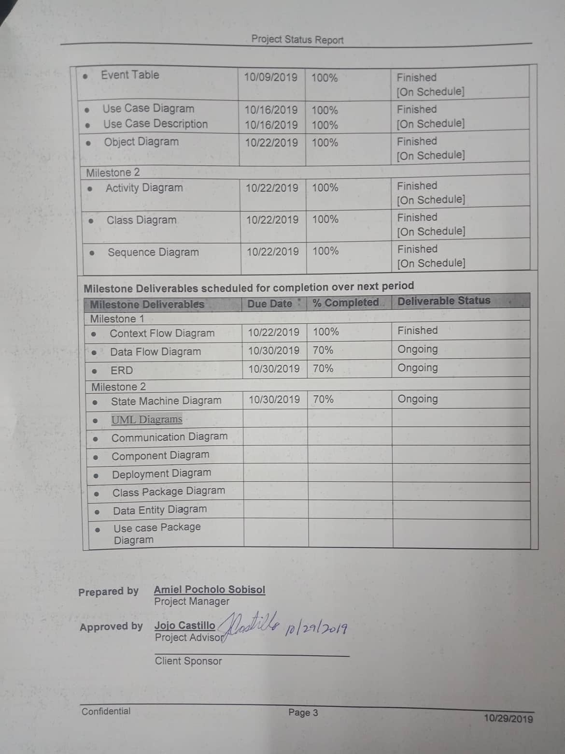



**Project Status Report**



**Project Name: Web-Based Entrance Examination with Course Recommendation**

**Department: SOCIT**

**Focus Area:** **MSYADD1/SYSADD2**



**Prepared By:**

|  |  |
| --- | --- |
| **Document Owner(s)** | **Project/Organization Role** |
| Amiel Pocholo Sobisol | Project Manager |
| Marlon Dayao | Programmer |
| Maverick Bolo | System Analyst |

**Project Status Report Version Control**

|  |  |  |  |
| --- | --- | --- | --- |
| **Version** | **Date** | **Author** | **Change Description** |
| 1.0 |  |  | Document created |
| 1.0 | 10/22/2019 | Marlon Dayao | * Event Table * Use Case * Use Case Full Description * Activity Diagram * Object Diagram * Class Diagram * ERD * State Machine Diagram |
|  |  |  |  |

**PROJECT STATUS REPORT PURPOSE**

The purpose of the report is to check whether the created diagrams is consistent with each other and to verify everything related to the subject by the project adviser.



# PROJECT STATUS REPORT TEMPLATE

## Project Status Report Details

* Ongoing

The purpose of this project is to mainly provide academic institutions with a web-based entrance examination with course recommendations to improve and replace the traditional method of giving the entrance examination.

The project is intended to prevent, minimize and improve the evaluation of entrance examinations. This project also intends to give Applicants an overview of the list of courses where they are suitable after taking the examination. With manual work processes, Administrators can only accommodate limited numbers of Applicants a day and it will take a period to finish checking and evaluating the papers.

The web-based entrance examination will provide immediate results of the examination and will generate reports to be used as a tool for marketing plan and/or decision making of the academic institution and has a data bank of created questions and this makes it a simpler method to give Test Admins to include the test rules and give a test in a completely organized system.[Milestone Deliverables for the last reporting period.]

## Project Status Report Template

|  |  |  |
| --- | --- | --- |
| **Project Name : Web-Based** | | |
| Prepared By:  Marlon F. Dayao Jr | Date:  10/29/2019 | Reporting Period:  10/30/2019 to 11/06/2019 |
| Project Overall Status:  Currently the project is ongoing since we are creating the diagrams needed to complete the project. It is also being check by our project adviser and professor. | | |
| Project Summary:  Web-Based Entrance Examination with Course Recommendation is a web-based entrance examination that will replace pen and paper methods of taking and giving entrance examination by providing generated results right after taking the examination and automatically give applicants the list of course recommendations based on the test score of the exam which will make it easier for the administrators to assess and give a briefing for the applicant about the most suitable courses. | | |
| **Milestone Deliverables performance reporting over last period**   |  |  |  |  | | --- | --- | --- | --- | | **Milestone Deliverables** | **Due Date** | **% Completed** | **Deliverable Status** | | Milestone 1 | | | | | * Event Table | 10/09/2019 | 100% | Finished  [On Schedule] | | * Use Case Diagram * Use Case Description | 10/16/2019  10/16/2019 | 100%  100% | Finished  [On Schedule] | | * Object Diagram | 10/22/2019 | 100% | Finished  [On Schedule] | | Milestone 2 | | | | | * Activity Diagram | 10/22/2019 | 100% | Finished  [On Schedule] | | * Class Diagram | 10/22/2019 | 100% | Finished  [On Schedule] | | * Sequence Diagram | 10/22/2019 | 100% | Finished  [On Schedule] | | | |
| **Milestone Deliverables scheduled for completion over next period**   |  |  |  |  | | --- | --- | --- | --- | | **Milestone Deliverables** | **Due Date** | **% Completed** | **Deliverable Status** | | Milestone 1 | | | | | * Context Flow Diagram | 10/22/2019 | 100% | Finished | | * Data Flow Diagram | 10/30/2019 | 70% | Ongoing | | * ERD | 10/30/2019 | 70% | Ongoing | | Milestone 2 | | | | | * State Machine Diagram | 10/30/2019 | 70% | Ongoing | | * [UML Diagrams](http://moodle2.apc.edu.ph/mod/url/view.php?id=35785) |  |  |  | | * Communication Diagram |  |  |  | | * Component Diagram |  |  |  | | * Deployment Diagram |  |  |  | | * Class Package Diagram |  |  |  | | * Data Entity Diagram |  |  |  | | * Use case Package Diagram |  |  |  | | | |

**Prepared by** **Amiel Pocholo Sobisol**

Project Manager

**Approved by** **Jojo Castillo**

Project Advisor

__________________________________

Client Sponsor